Lab03 : Python Loops
Name | Nneoma Onwe
Date | 06/02/23

Exercise 1: While Loop
Using a while loop, modify the program lab3ex1.py below so that the user is asked to enter a numbeir in the range 1 and 10. If the number enters an out of range number then the program should loop until a valid number is inputted.

Copy your Python code here. Make sure that your code contains your name and date.
#Nneoma Onwe
#06/02/2024
#LAB 2 EX 1
# we were ask to ask the user to enter a number between 1 and 10

#Assing the variable number and ask the user to enter a number
number = int(input("Enter a number:"))

# Using a while loop to range number from 1 to 10
while number <= 0 or number >= 11:
# Display the number between 1 to 10
print("Invalid number. Please enter a number between 1 and 10.")

number = int(input("Enter a number:"))
# Display the number
print(number)

Paste screen capture here showing the program being run

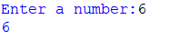

Answer the following questions in it:

- What is the purpose of the loop in your program?
The program's loop is designed to repeatedly prompt the user to enter a number between 1 and 10 until they enter a valid number. If the user enters an invalid number, the loop will repeatedly prompt them to enter a valid number. When the user enters a valid number, the loop ends and the program displays the number.

Exercise 2: Validating User Input
Using a while loop, write a program lab3ex2.py that asks the user for a user name. If the name entered by the user is NOT equal to “Mary” then the program should loop until the user enters the correct name.
Copy your Python code here. Make sure that your code contains your name and date.
#Nneoma Onwe
#06/02/24

#Assign the variable username and ask the user to enter a username
username = input("Enter a username:")
#the username is not equal to mary
while username != "mary":
#Display the username
print ("please enter a username \n")
username = input("enter a username \n")
#print the username of the user input
print (username)

Paste screen capture here showing the program being run
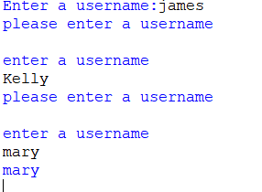

Answer the following questions in it:

- How does Python differ from C when comparing two strings?
In Python, the == operator is used to compare two strings. To compare two strings in C, use the strcmp() function from the <string.h> library to see if their contents are the same. The strcmp() function compares the contents of two strings character by character and returns an integer result.

Exercise 3: Counter Controller Loop
Using a for loop, write a program lab3ex3.py that displays the numbers 0 to 31.
Copy your Python code here. Make sure that your code contains your name and date.
print("Dispaly the number 0 to 31")
for number in range(1,31):
print (number)

Paste screen capture here showing the program being run
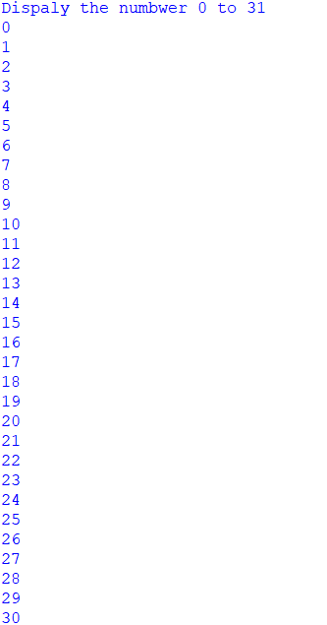

Answer the following questions in it:

- What is meant by a “counter controlled loop”?
The counter variable is typically initialized before the loop starts and incremented or decremented with each iteration of the loop. This type of loop is useful when you know exactly how many times the loop should run..

Exercise 4: Counter Controller Loop
Exercise 4
Using a for loop, write a program lab3ex4.py that displays the IP addresses 192.168.1.1 to 192.168.1.63
Copy your Python code here. Make sure that your code contains your name and date.
for i in range(1, 64):
ip_address = "192.168.1." + str(i)
print(ip_address)

Paste screen capture here showing the program being run
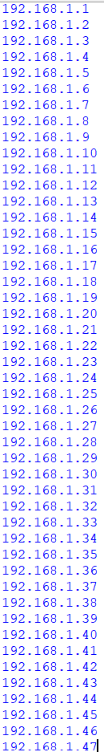

Answer the following questions in it:

- What is meant by concatenation?
Concatenation is when it joins one or two word together to create a new string

Practice Exercise
Using the Python control structures covered in week 2 and week 3, attempt the following exercise to consolidate your understanding of branches and loops.

Exercise 5
Assume we have three login usernames on a system with the following passwords:
username | password
student1 | networking101
student2 | networking102
student3 | networking103
Write a program that asks the user to enter a username and the corresponding password.
If the user enters a correct username and password then the message “Successfully logged in” should be displayed. If the user does not enter a correct username then the program should re-prompt them until they enter a correct username. If a valid username is entered but the password is not correct, then the user should be re-prompted to enter a correct password. The user should not get more than 5 attempts at entering a valid password.

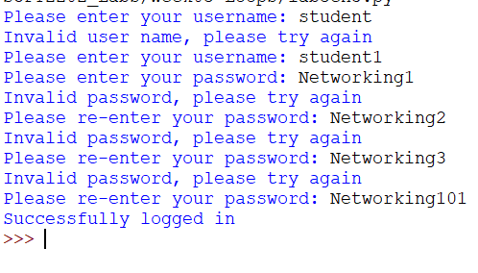

Copy your Python code here. Make sure that your code contains your name and date.
# Nneoma Onwe
# 06/02/24

# Assign the username and password
# The user enters a username and password
attempts = 0

while attempts < 5:
# Reset attempts for each loop iteration
attempts = 0

# Ask for username and password
username = input("Enter a username: ")
password = input("Enter a password: ")

# Attempt to log in with student1 credentials
while username != "student1" or password != "networking101":
attempts += 1
if attempts == 5:
print("Maximum login attempts reached. Please try again later.")
exit()
print("Invalid username or password. Please enter the correct credentials.")
username = input("Enter a username: ")
password = input("Enter a password: ")

print("Successfully logged in!")
break # Exit the loop if login successful

while username != "student2" or password != "networking102":
attempts += 1
if attempts == 5:
print("Maximum login attempts reached. Please try again later.")
exit()
print("Invalid username or password. Please enter the correct credentials.")
username = input("Enter a username: ")
password = input("Enter a password: ")

print("Successfully logged in!")

while username != "student3" or password != "networking103":
attempts += 1
if attempts == 5:
print("Maximum login attempts reached. Please try again later.")
exit()
print("Invalid username or password. Please enter the correct credentials.")
username = input("Enter a username: ")
password = input("Enter a password: ")

print("Successfully logged in

Paste screen capture here showing the program being run. Show tests for both valid and invalid user input.
